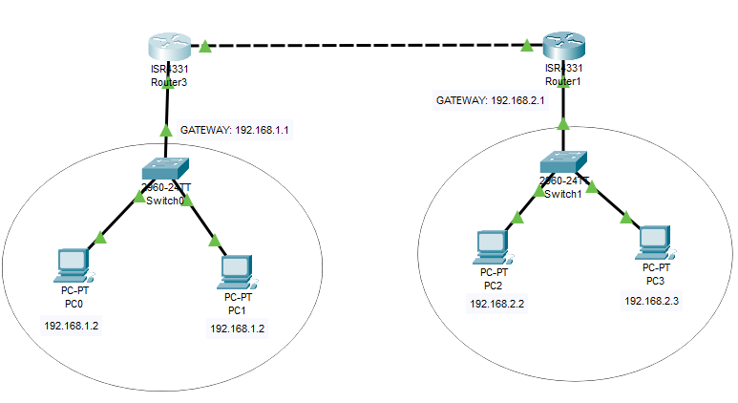

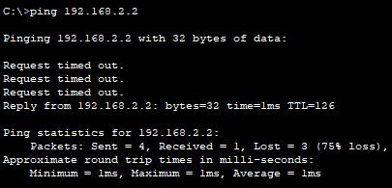

ROUTER 1:

Router>enable

Router#

Router#configure terminal

Router(config)#interface GigabitEthernet0/0/0

Router(config-if)#ip address 192.168.3.2 255.255.255.0

Router(config-if)#no shutdown

Router(config-if)#

Router(config-if)#exit

Router(config)#interface GigabitEthernet0/0/1

Router(config-if)#ip address 192.168.3.1 255.255.255.0

Router(config-if)#no shutdown

Router(config-if)#interface GigabitEthernet0/0/1

Router(config-if)#ip route 192.168.1.0 255.255.255.0 192.168.3.1

ROUTER 2:

Router>enable

Router#

Router#configure terminal

Enter configuration commands, one per line. End with CNTL/Z.

Router(config)#interface GigabitEthernet0/0/0

Router(config-if)#ip address 192.168.3.2 255.255.255.0

Router(config-if)#ip address 192.168.2.1 255.255.255.0

Router(config-if)#no shutdown

Router(config-if)#exit

Router(config)#interface GigabitEthernet0/0/1

Router(config-if)#ip address 192.168.3.1 255.255.255.0

Router(config-if)#no shutdown

Router(config-if)#interface GigabitEthernet0/0/1

Router(config-if)#ip route 192.168.1.0 255.255.255.0 192.168.3.1